Casey Bladow

5/6/2013

Media Writing

Final Paper – Americans’ Confidence in Television News Drops to New Low

A July 10th Gallup Poll reveals that, in general, American’s confidence in Television news and newspapers is at an all time low. With only 21% expressing a “a great deal”/”quite a lot” of trust in mainstream news outlets. This greatly shows the need and want for alternative news sources in America and demonstrates a major problem in mainstream news today. (Mirkinson, 2012)

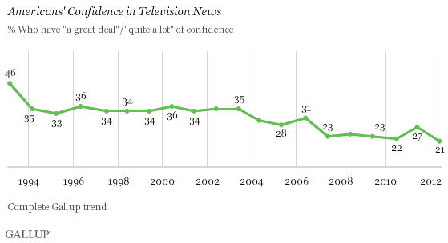

(Morales, 2012)

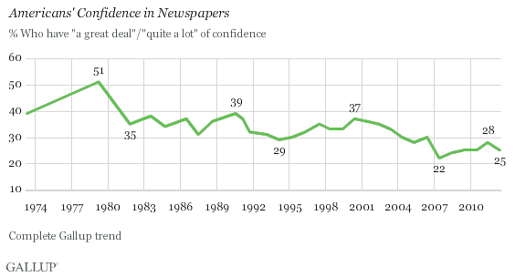

(Morales, 2012)

Gallup is a polling firm that does an annual survey on the confidence that Americans have in their biggest institutions. Gallup also noted that its survey took place before CNN and Fox News botched the Supreme Court’s ruling on President Obama’s health care law, likely to emphasize just how little faith the American people still have in their mainstream media newscasts.

When discussing the issue of critical thinking and staying informed with a good friend of mine, John made some very intriguing statements, “It's not about being informed, it's more about people not wanting to think about the information that they're given. People are losing the ability to reason and question information critically, and there are a number of different causes to blame. The world isn't getting less intelligent, it's getting more compliant.” Following that very interesting and almost philosophical comment with “That's why I believe nothing, and question everything. Answers to where, when and what are inconsequential compared to how and why. The pursuance of the latter are what build a good foundation for a greater capacity of understanding. And in the end, I would rather understand and be labeled as crazy, than be normal and compliant. I am free thought, I am free.” (Anderson, 2013)

I really believe that after the recent Boston bombings and the countless number of times CNN and other major news stations had the information wrong we will continue to see an even further decline in confidence of our mainstream media. I can personally say that I get very little of my news from any of them anymore, and definitely not without doing some research and gathering multiple sources of my own. I believe too many stations have been striving to be the first to get you “the latest breaking news” that they have forgotten the rules of fact checking and gathering sources. Not only do many stations make these critical errors but the level of bias you receive from each station has almost became too much to handle. I can personally say that I will not even tune into certain stations just because of how they analyze and deliver the news.

Journalism at the mainstream level has lost its way and I believe when only 21% of the nation has a great deal of trust in you it’s pretty clear to see that. When every major station has a clear bias on how and what they inform the public on, than any ethics and respect they once had has been lost.

# Bibliography

Anderson, J. W. (2013, 4 25). (C. Bladow, Interviewer) Fargo, ND, USA.

Mirkinson, J. (2012, 7 11). *Gallup Poll Finds Confidence In TV News Has Hit A New Low*. Retrieved 5 5, 2013, from The Huffington Post: http://www.huffingtonpost.com/2012/07/11/gallup-poll-confidence-tv-news_n_1664429.html

Morales, L. (2012, 7 10). *Americans' Confidence in Television News Drops to New Low*. Retrieved 5 5, 2013, from Gallup: http://www.gallup.com/poll/155585/Americans-Confidence-Television-News-Drops-New-Low.aspx?utm_source=alert&utm_medium=email&utm_campaign=syndication&utm_content=morelink&utm_term=All%20Gallup%20Headlines%20-%20Politics

I choose this topic because I think there is a major problem with the lack of information people are receiving. Not only is it bias and just plain false on occasion, people would rather be informed on what Lindsey Lohan got arrested for over the weekend. I think there’s a major problem with our country when distractions (sports, Facebook, Twitter, etc.) and the news of ‘celebrities’ has became more important and influential then real news. The things that are happening in congress and right in front of our eyes but we’re too distracted to see. Boston was completely shut down and turned into a Police State in the matter of hours. People lost all of their constitutional rights and were being forced at gunpoint to allow house-to-house searches by SWAT teams armed to the ‘T’ with no warrants or probable cause. That should scare you! The reaction of our military and police should frighten you more then the bombing itself. It was a clear violation of civil liberties, not to mention unsuccessful, since Dzhokhar was discovered by a resident AFTER the lockdown was lifted.

I couldn’t have possibly worded it better then John did. “People are losing the ability to reason and question information critically… The world isn't getting less intelligent, it's getting more compliant.” I think what happened in Boston is a clear cut example that we just rolled over and have let our civil rights slip thru our fingers. This is a very dangerous slope and people really need to wake up and start informing themselves of these things. We cannot give up our constitutional rights so that the government can pretend to protect us. John and I have conversations all the time. He has 3 different B.A. degrees from MSUM and is one hell of a smart guy. This particular conversation was a couple weeks ago via Facebook messenger and I actually had no idea what my paper was even going to be on yet.

I guess I don’t know a specific publication I would put it in, beings it ended and was summed up with my own thoughts… maybe like a “Dear Casey” of any local publication. I really needed to add that though to add some length to the story. Its easy to say that people are losing faith in the system and mainstream media but stretching out a few statistics made it difficult. So, maybe just a personal blog of some sort. Or, cut up the story after Johns quote and then run it everywhere. It’s probably safe to say that most people don’t even know this poll took place… so with that said it may not be 100% accurate. Kind of a catch 22…

This is a story comparing Michael Vick and Dr. Kermit Gosnell. Why is there a media blackout covering this?? Why does the media go crazy to report about something an NFL player did but ignores stories that actually matter…

<http://communities.washingtontimes.com/neighborhood/lower-9th-ward-conservative/2013/may/5/irony-contrast-michael-vick-and-dr-kermit-gosnell/>

<http://nation.foxnews.com/dr-kermit-gosnell/2013/05/03/shame-you-mainstream-media-kermit-gosnell-who>